**Thin, Flexible Absorbent Cores**

Cores in absorbent products like baby diapers or adult incontinence articles have to fulfill a number of different requirements.

⦁ They need to provide the required storage capacity

⦁ They need to take on fluid fast enough to prevent portions of it leaving the product

⦁ They need to provide sufficient core integrity to avoid core cracks in dry and wet state

⦁ They need to provide sufficient stability under load, like being excerted by a person sitting on

a loaded product

⦁ They should be discrete, both in dry and wet state, especially in AI products

⦁ They need to be thin and flexible like normal underwear

Last not least, cores in disposable absorbent products should utilize the materials they are made off to the maximum degree possible.

**Background**

For decades, cores in disposable absorbent products were made by mixing supersorber particles (SAP) and cellulose fibers (fluff). The more fluff was used in the storage core, the better its integrity and liquid transport capability, at the expense of thinness, flexibility and aquisition speed.

Recently, products with thinner cores were introduced into the market. They all have in common that their content of fluff is either significantly reduced or even „0“. Some of them use a significant amount of glue to deliver the required integrity performance. Others are designed to deliver this function by anclosing the SAP particles in small „islands“. Another common design element of such products is the use of higher amounts of acquisition and distribution material (ADL) to ensure the core takes on and delivers liquid fast enough to avoid leaks.

Unfortunately, these design concepts do not make best use of the materials utilized: The ADL improves acqusition and distribution speed, but does not contribute to the dry and wet integrity performance of fluffless cores, and their discreteness on the wearer.

**The New Invention: Embedded SAP Cores**

The cores presented in this invention feature a fibrous matrix as „embedding layer“ – preferrably formed by the ADL material, or at least a portion of it – in which SAP particles are embedded. When introduced into the product making machine, the embedding material has wide pores, big enough to let portions oft he SAP go inside or even through the ADL material, while the bigger particles remain on the top oft he ADL layer. In a preferred execution, a polypropylene (PP) layer is added below the ADL as carrier layer before the SAP is introduced, and another PP-layer is laid on top of the ADL as cover layer after the SAP has been added. This sandwhich is subsequently bonded ultrasonically, whereby cover and carrier layer are connected to each other by means of elliptical bond regions.

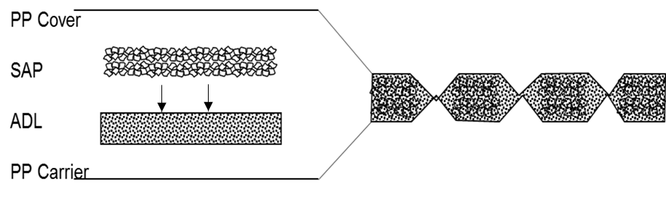

Consequently, the pore size of the ADL material, which is now compressed between carrier and cover layer, is reduced such that the dry SAP particles enclosed can no longer move freely, but rather are kept in position, even if the dry core is manipulated significantly.

Elliptical bond regions

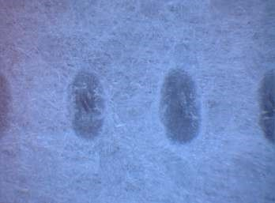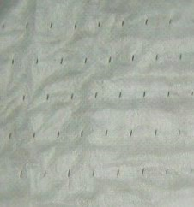

When the core is loaded, two things happen in parallel:

⦁ The SAP particles grow in size, thereby cracking the bonds between carrier and cover layer

⦁ By growing in size, the SAP particles become too big to move inside the structure of the

embedding layer

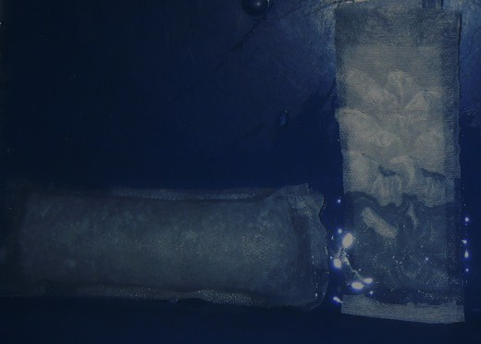

demo-core

sample

dry

….wet

Bottom line: The ADL material does not only provide the acqusition and distribution function for which it is normally used, but it also ensures dry and wet integrity performance, and the effects they have on comfort and discreteness.

piece of loaded

core w/o carrier

hanging on a

hook

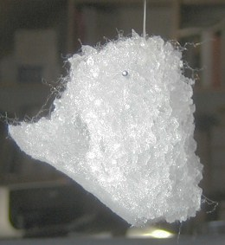

Other executions, like cores featuring more than one embedded SAP layer, are within the scope of this invention, as are cores with other materials like tissue or fluff added inside the structure delimited by carrier and cover layer. They all have in common that bond points join the outer layers, the bond points being strong enough to withstand manipulation of the dry core, and weak enough to break when the SAP particles grow in size.

Link to D:\Homepage\HomepageDateien ok