What are 3D absorbent products? Why are they needed?
A look at the anatomical givens of the human lower torso may help to answer these questions.
The lower torso and the upper sections of the legs, all of them three dimensional and essentially formed like cylinders or sections thereof, intercept in the crotch area - where diaper products are worn. Each of these “body parts” - 4 in total, namely 2 legs, waist and crotch - by itself could be perfectly wrapped with a two-dimensional piece of material, but it is geometrically impossible to achieve a snug body coverage for a “leak proof” fit – and comfort for the wearer - by wrapping the “assembled lower torso sections” with only a single 2D piece, as most current diaper and pants products try to do.

Current products - please see the sketch below - wrap only two of the four torso parts with a single 2D sheet (centre sheet), namely the waist and crotch. The centre sheet needs contractive elements on the sides, to make them stand up to fit into the crotch crease. The upper side (waist) areas of the sheet are combined to close the product around the wearer’s waist. The legs are not really wrapped; they just push the centre sheet out of their way, thereby generating partial, not very well defined wraps around the legs.

In contrast to this, 3D products provide 3 sheets, which are assembled such that they wrap all parts of the lower torso, as shown in the sketch below. The product assumes a “body-like” shape when applied.. It has dedicated 2D sheets to wrap the legs like concentric bands. These bands are fixed to the sides of the centre piece and maintain its 3D cup-like shape. The product can even take a body-like shape when it is not on the wearer - and it does not need any elastics to conform to the body.

Such products - we call them BOCO FIT (Body COnforming FIT) products - maintain a cup shape in the crotch area due to the design inherent arrangement of leg hoops to the centre chassis region. This implies that a user does not need to generate or withstand any forces to bring or keep the product in shape, like on current products. It also means there is almost no force needed to put the product on, unlike on current. This speaks first of all to the comfort aspect, but also to reduced pressure on the skin and less red marking. It also speaks to lower material specifications, lighter fastening systems, and less sophisticated materials.

Another important feature of BOCO FIT products is the way how they are assembled. The side areas are put on top of the centre piece in a “stacking mode” and affixed by butt type connecting lines using Ultrasonics. This allows to introduce “darting”, a well known technology used in textile manufacturing. Darting allows to fit the product design to any body contour without needing any elastic elements.

The red lines represent Ultrasonic connecting lines which fix siede areas to the centre piece. When the product is opened for use it looks like in the following schematic.

erected leg hoops,
unfolded sidepanels

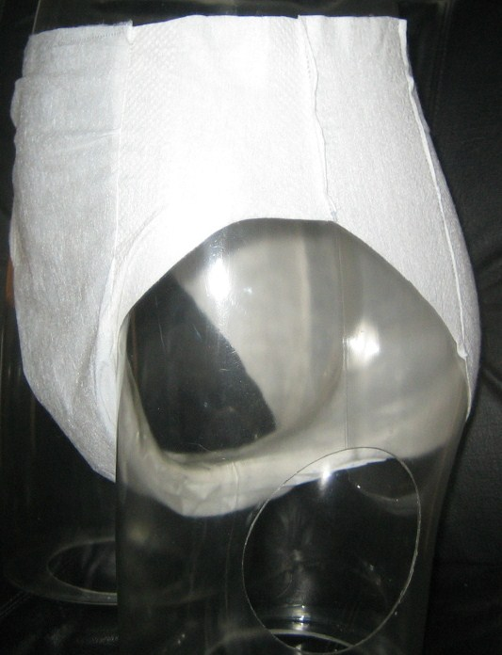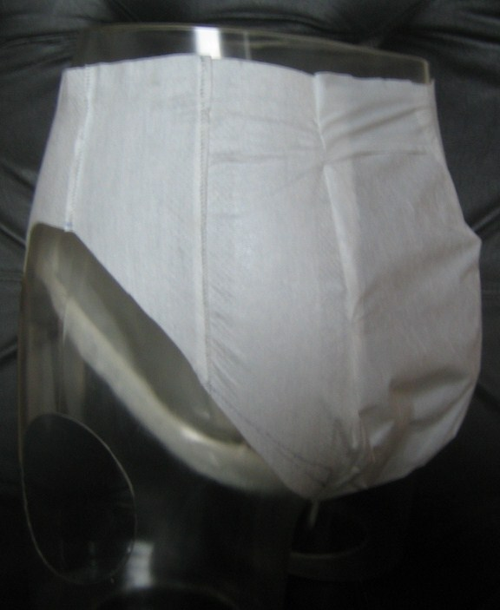
C4S
–
technical know
how & creative solutions
BOCO
Sonic
Products
-
AI Pants
-

