BOCO SONIC DISPOSABLE ARTICLES

Summary
BOCO SONIC hygiene articles are underwear-like, body conforming products made without any construction glues and without elastic elements contracting in front to back direction. All components composing the articles are processed, combined, and packed in flat, non-tensioned state. Once unfolded upon use, they take on a non-flat, 3D shape, fitting the lower part of the human body. BOCO SONIC products can be made available in all sizes for babies and adults.
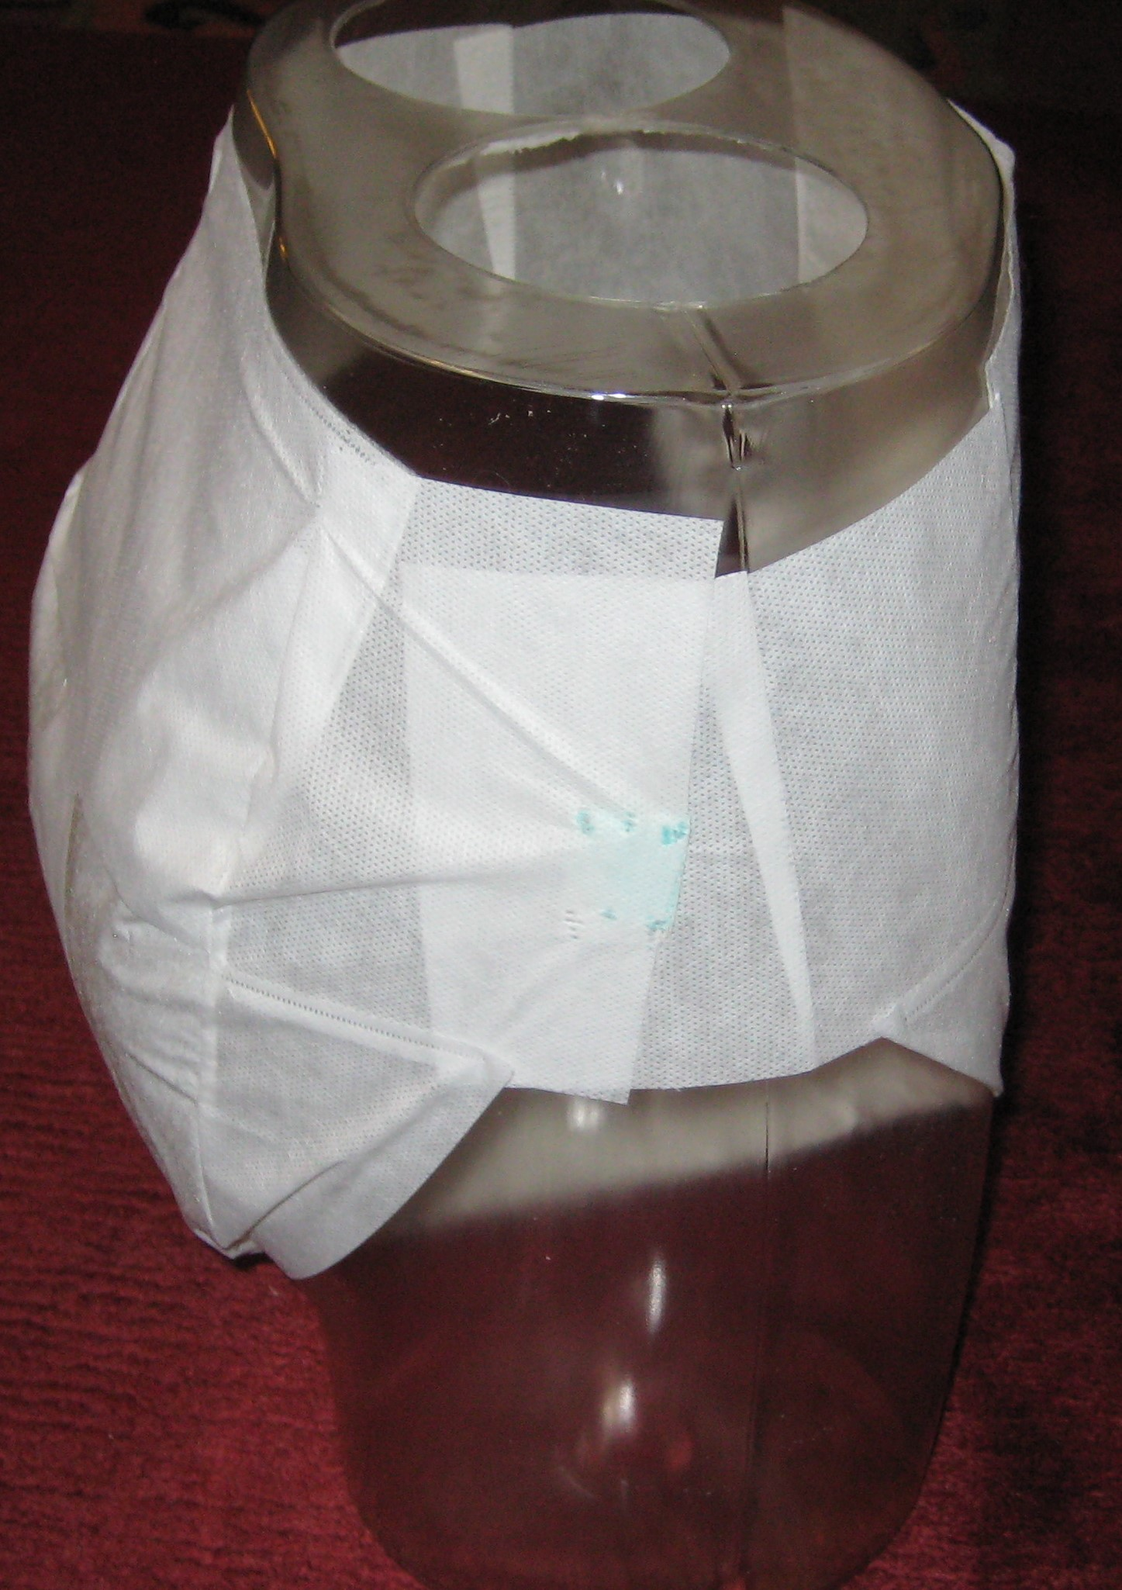

Details
BOCO SONIC products are different to current products in many areas. First of all, they use “darting” technique to join parts of the article together. Darting is well known in the textile industry, where parts of an article are often sewed together in a darting relation, but so far has not been introduced in the mass production of disposable articles. Reason may be the lack of a suitable combining technique that reliably makes soft bonds between thin nonwoven web pieces. This technology - the “helibond” technology, where a helical anvil roll works against an ultrasonic agitator - is proprietary technology of C4S, and is further developed jointly by Herrmann Ultraschall and C4S.
The basic effect of darting is the formation of a 3D shape which an article takes on in use, the article being composed of flat (2D) web pieces joined together along non-linear combing lines or areas. This C4S technology marketed by BOCO TECH AG can be implemented in various product executions which are pooled under the BOCO FIT™ trademark. Darting has a similar effect on an article like front to back contracting elastics in a conventional absorbent product. Consequently, such elastics are no longer needed in BOCO FIT™ products to deliver an article fitting the lower human torso. This marks the second major difference of BOCO FIT™ products compared to conventional products.
The absence of front to back contracting elastics has several side effects, the most important ones being that:
- The centre piece of the products can be designed smaller, particularly shorter, because the shortening effect of front to back contracting elastics is gone. And
- All product surfaces contacting the body are in flat, non-tensioned state. There are no wrinkles or ruffles causing high local pressure on the skin and potentially skin marking and irritation. And
- Sealing against fluid leaving the article is enhanced due to the flat structure of the sealing surface contacting the skin.
A third major difference is a high flexibility, ultrathin, sonically bonded absorbent core, made on the HELIBOND Core Former. In these cores, the superabsorbent granules are “embedded” in a polyester layer which is bonded between outer PP-based carrier and cover layers. The polyester layer is similar in kind and functionality compared to “ADL” layers in conventional products, the difference being its function of immobilizing SAP granules both, in dry and wet state. The embedding design and making technology employed in BOCO SONIC products has also been invented by C4S. It requires the rotating sonotrode technology developed by Herrmann Ultraschall.

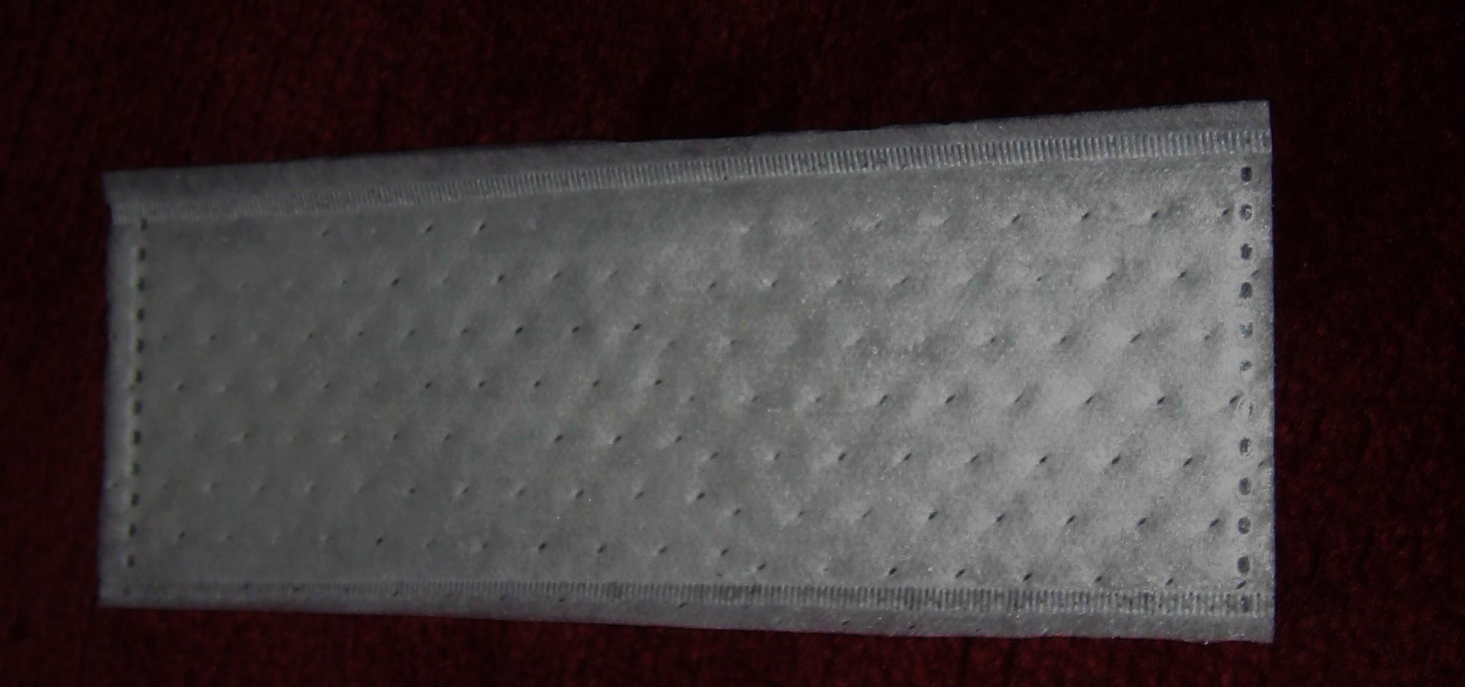

SAP granules are forced by gravity and air streams generated by vacuum into the rather open structure of the embedding web, which is subsequently bonded between the outer carrier and cover webs. While relatively strong bonds are formed between the pp-based outer layers, the polyester layer is mainly compressed between the outer layers forming the bonds. This compression reduces the size of the material pores, also of those pores in which SAP granules have been located, preventing their undesired migration. Upon loading, the bonds between the outer layers are cracked, and the embedding layer’s pores grow beyond their original size, this all being driven by the swelling SAP-granules. The loaded cores feature unsurpassed wet integrity because strong polyester fibres are spanning around pores holding loaded SAP granules reliably in place.

The embedding layer’s dual functionality helps thinness, both in dry and wet state: when dry, the pore size of the layer holding DAP granules is reduced, making the material thinner. In wet state, the fibres of the embedding layer spanned around loaded SAP particles do hardly add to the core’s overall thickness. The “embedded SAP” core technology may be utilized in conventional products and BOCO FIT™ products.

The fourth differentiating factor between conventional and BOCO SONIC products is the absence of any glue in the product. This seems to be only feasible in BOCO FIT™ type products. The absence of glues has a number of advantages:
- The layers constituting the product are only connected by dots, rather than lines or wider areas. This gives a much softer feel of a composite than any glued-together structure can provide. Glues always join major neighbouring areas of contacting webs, thereby forming more solid, less flexible, less soft fibre structures than any of the base webs contained.
- The absence of glue helps production efficiency: There is no undesired glue build-up causing machine downtime for cleaning or even web breaks.
- The absence of glues reduces production scrap. When a line stops, almost all products effected by the stop need to be scrapped, because the glues cool down and will not function any more until the line is at speed again.

Finally, the absence of glues comes with a significant reduction in capital costs of a production system - aside the going cost reductions due to a cheaper formula of the product. The absence of glues and elastics, together with a smaller size centre piece, enables manufacturers to further expand hygiene products into new markets worldwide, also in low income regions, with positive impacts on the quality of life as well as the environment.

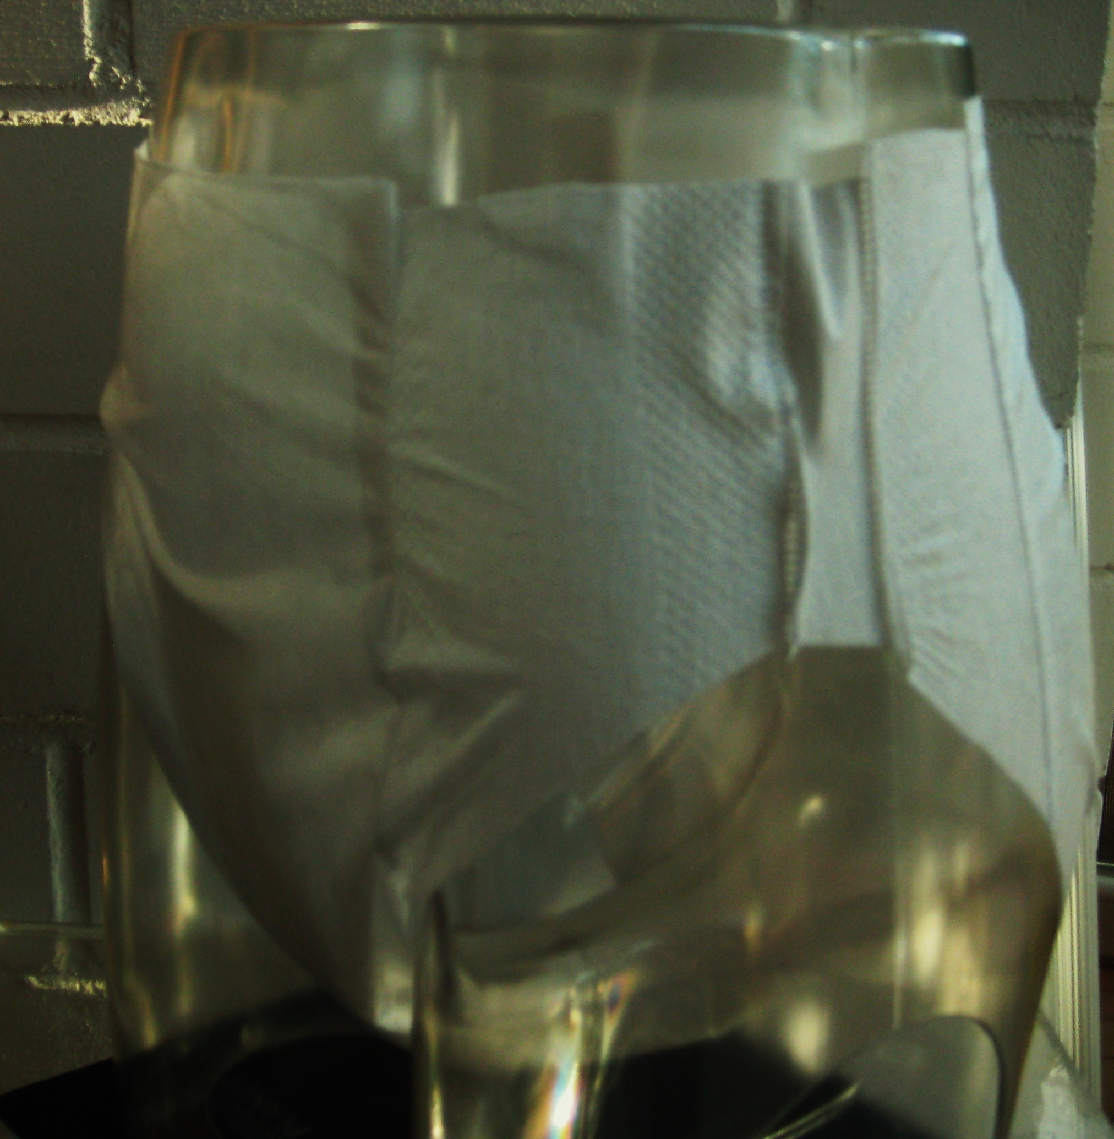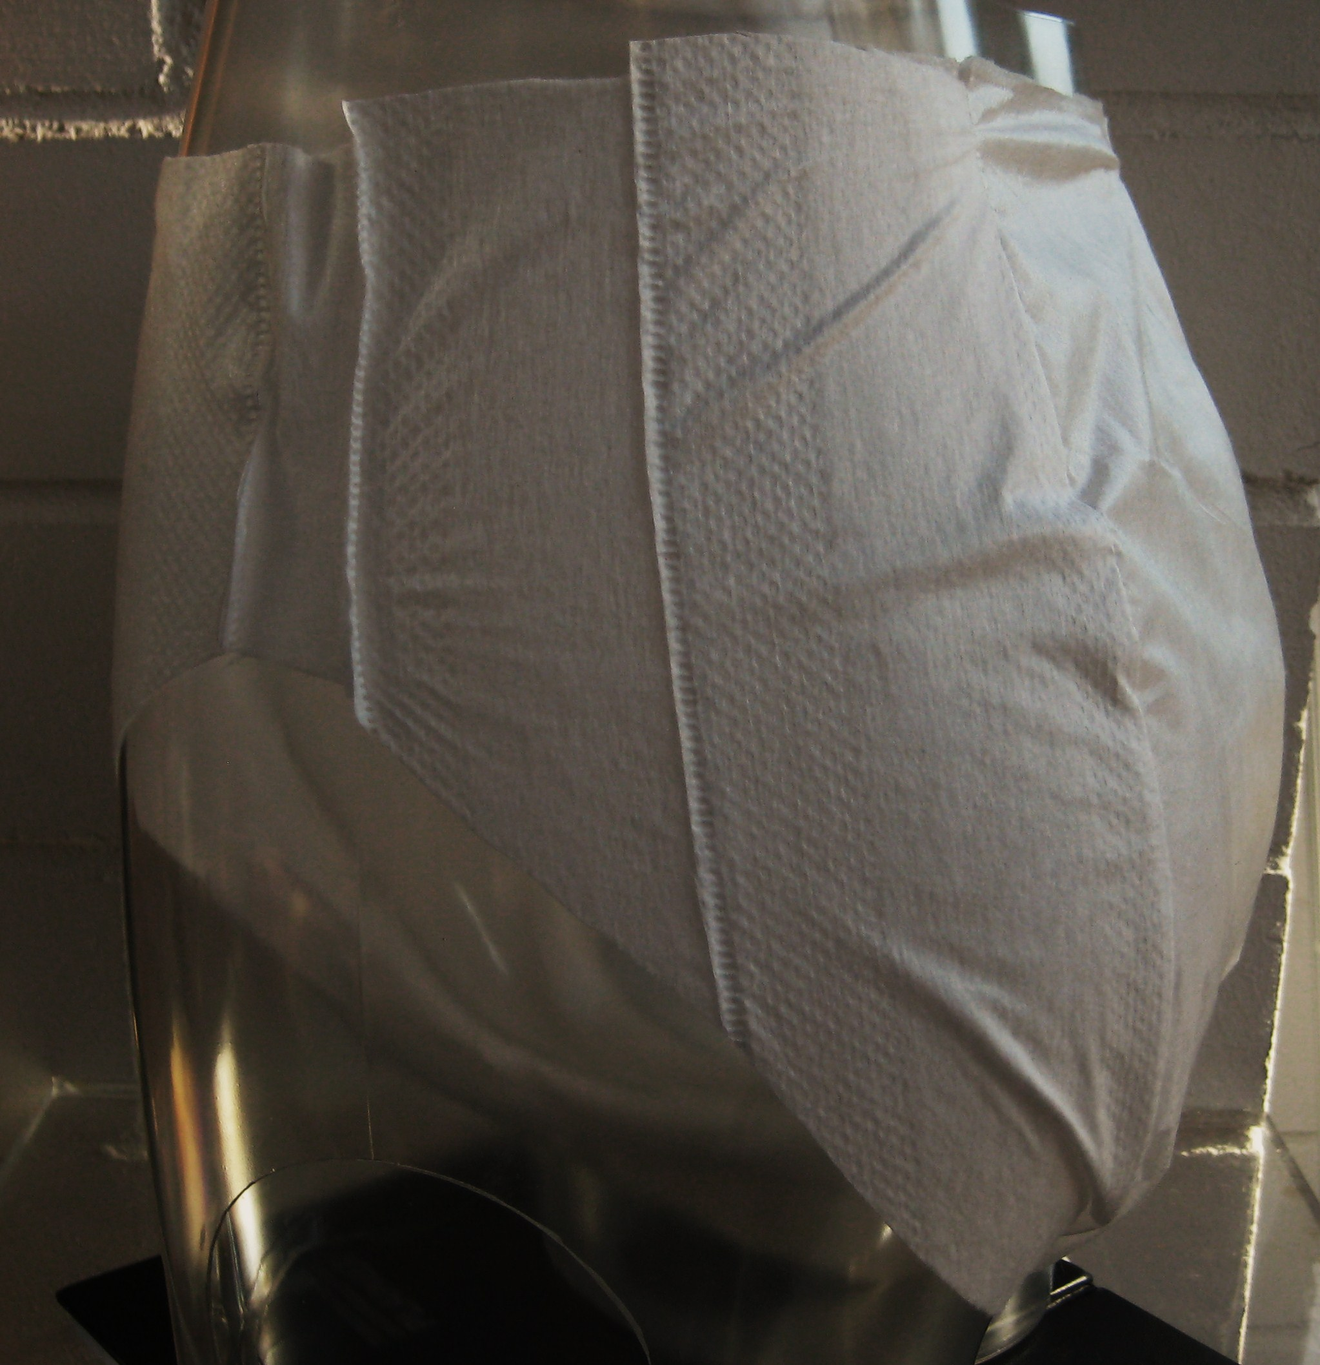


- „GLUE FREE DIAPER“ in der Category 7 (“Sustainable process or management practice”)

- „HELIBOND CORE FORMER“ in der Category 5 (“lnnovation in machinery of special relevance to the nonwovens industry”)

