What can a product with faeces separation capability look like ?

Products available in the market today almost exclusively focus on parameters describing their fluid handling capabilities. There are neither data available nor agreed methods defined to generate data which measure a product’s performance in the context of solid waste handling. The reason may be simply that there is no product concept available today that could deliver reliable performance in this matter.
3D products by design offer some important features which seem to be intrinsically tied to a functioning “BM Encapsulation” product. These are:

- precise placement of areas of the product relative to the wearer’s anus
- sustained fit, even when the product is loaded
- void space underneath a skin contacting sheet

- topsheet with
slit/hole fixed to
upper portions of
leg hoop
- topsheet shortened
in length and width

topsheet held close to the anus

A general design concept for products providing faeces separation capability may lead to a design like the one shown above. The waist part of the product is left away to see the void space into which solid excrements can be discharged, and stored. The topsheet may extend all the way from the front to the rear end of the crotch part of the centre piece. On its sides, the topsheet is anchored close to the upper ends of the leg hoops - which are placed all the way up in the wearer’s crotch crease when the product is used. The precise anchoring of the cup shaped void volume to the leg hoops ensures the product stays where it was put initially, throughout the wearing period.
The width of the topsheet between these anchoring areas to the leg hoops can be designed to match the narrow gap between the legs, such that the topsheet is held flat and unfolded against the skin close to the anus. Such design is hardly feasible with current products.

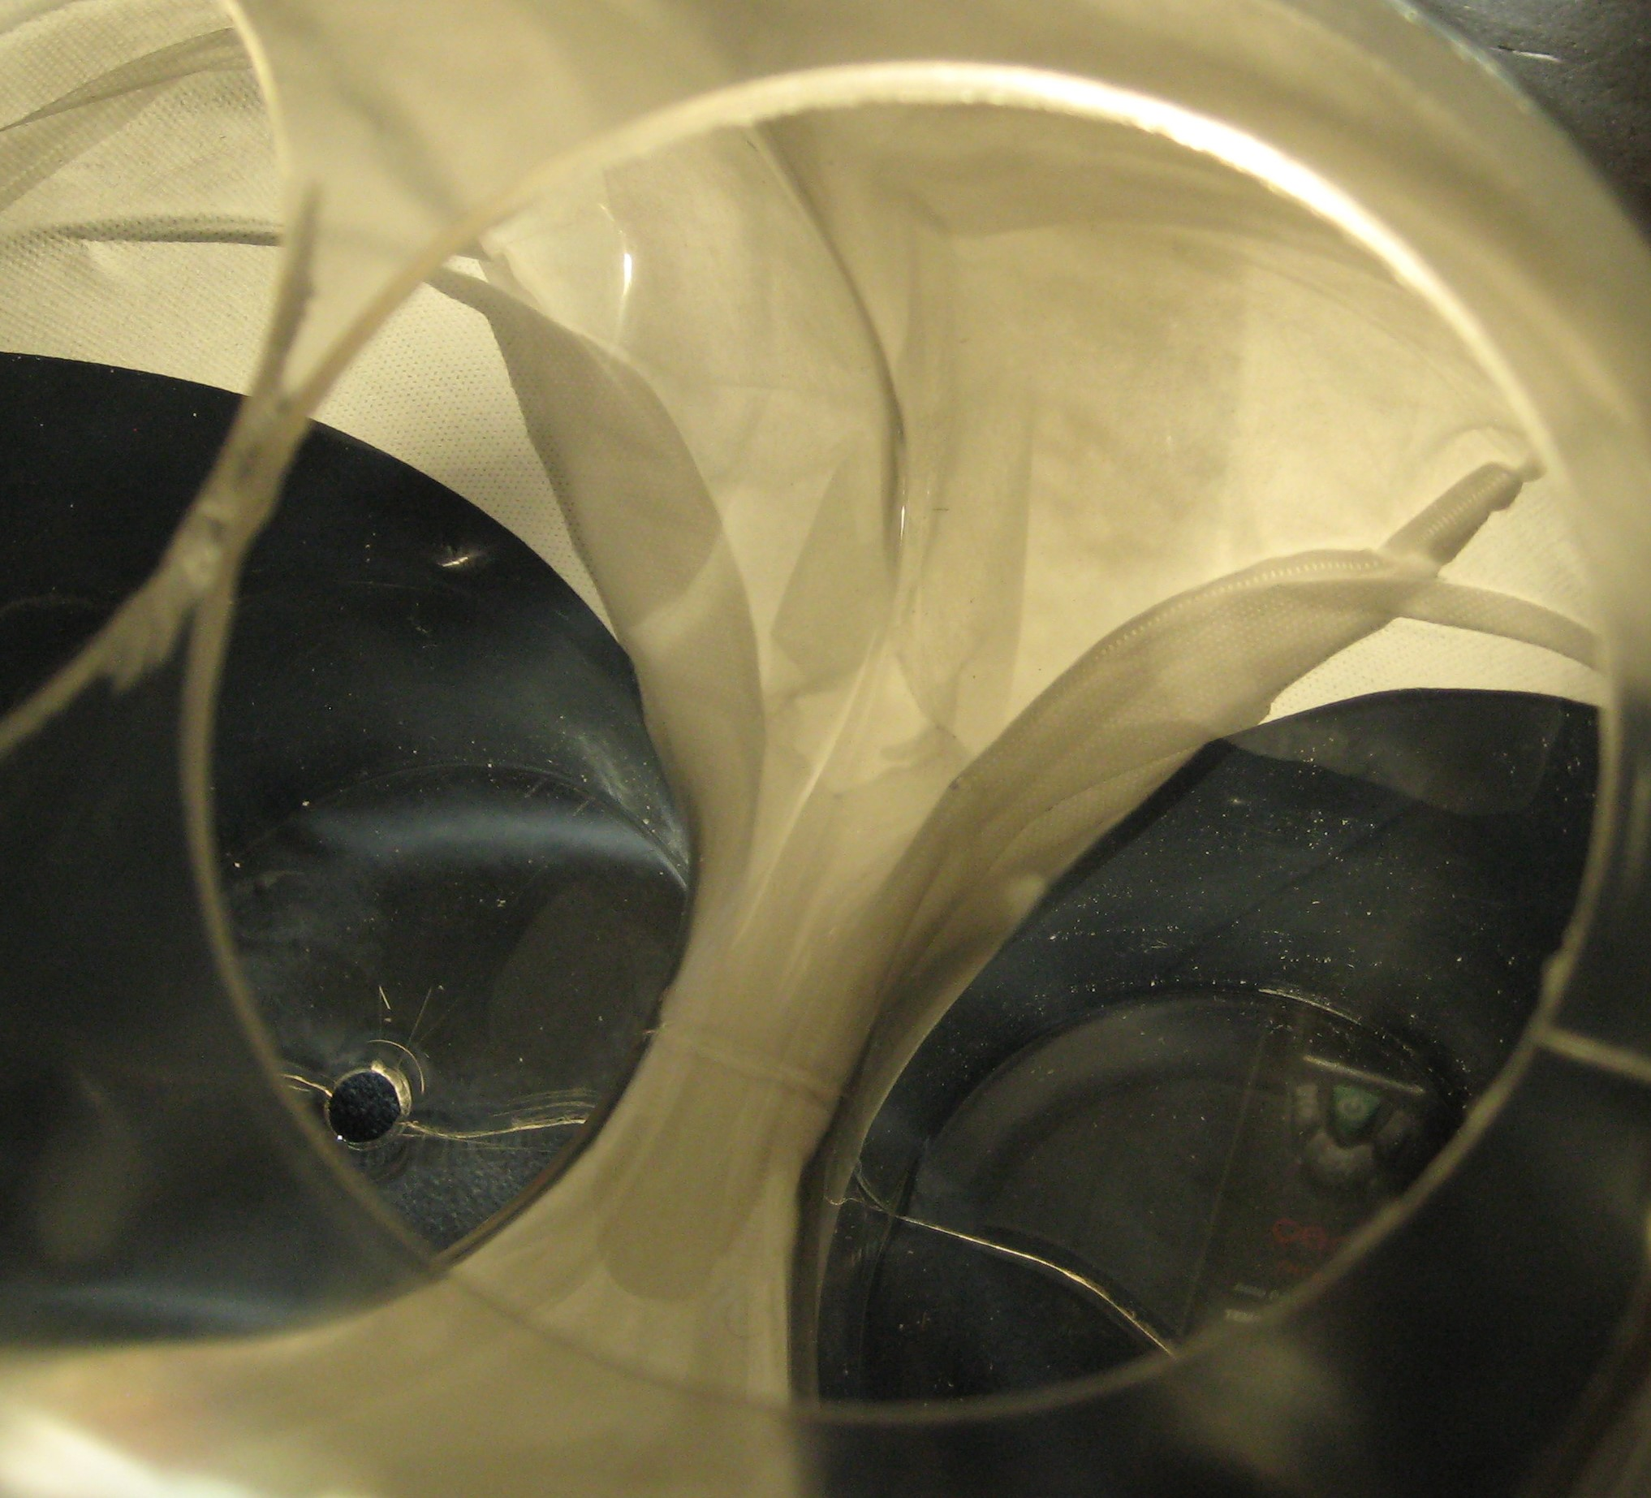
slit opened up
due to fixation
of topsheet
to leg hoops

The secondary topsheet is fixed to the leg hoops which lift it up against the wearer’s skin when the product is worn. There is no material spanning front to back or left to right over the anus, preventing excrements to get straight into the product. Alternative embodiments with other openings, elastic elements, additional topsheet shortening etc. are possible.
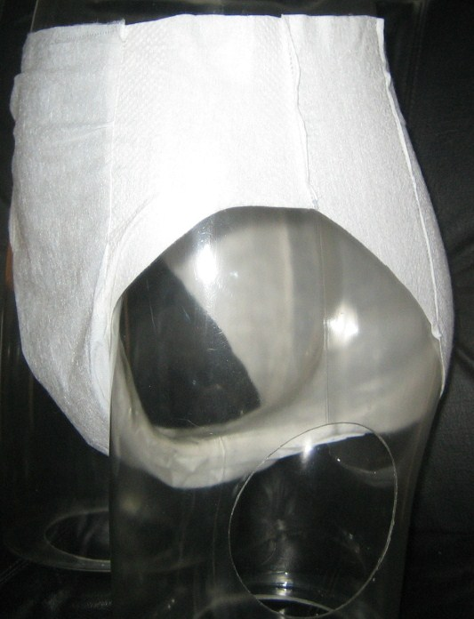
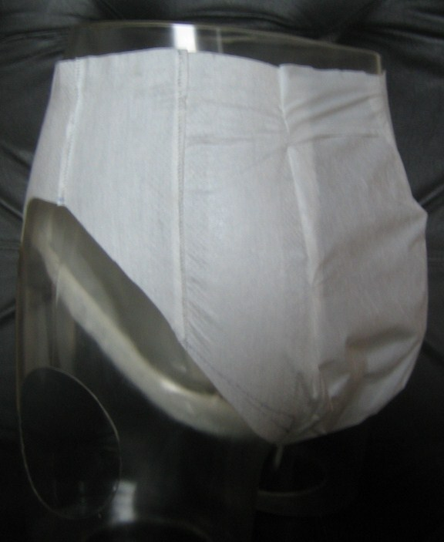
C4S
–
technical know
how & creative solutions
BOCO
Sonic
Products
-
AI Pants
-

