BOCO FIT® CONTOUR - The Family of 3D Anti Rash Pant and Diaper Products

Rash is a very common skin problem for people wearing absorbent pants or diapers, frequently experienced by both, babies and adult wearers. There are a number of reasons promoting the development of a rash - some of them related to the person using an absorbent product, others related to the product itself. In this write up we want to focus on one of the product induced rash promoters only.

A listing of factors causing rash is often showing the force a pant or diaper inserts on the skin as the number 1 factor. The higher the force, the bigger is the risk for the skin to be hurt. The normal force on the skin - and resulting friction forces - open small passages e.g. for bacteria to enter the skin and inflame it. It is therefore a stated objective of BOCO FIT® products to reduce the force levels in the product as much as possible and desirable.

In some other articles on this side, a diaper fit model, and product solutions derived from this fit model have been presented. The model describes the lower torso as being assembled of essentially cylindrical elements, or sections of cylindrical elements. The upper leg areas are in fact formed like cylinders, and the hip areas and crotch are formed like sections of cylindrical elements. This model has helped to develop products without leg or cuff elastics which - in conventional products - are combined under tension to layers of web materials, like fabrics. When releasing the combining tension, such products form gathers which are often harsh, and have the potential to irritate the skin of the wearer.

However, the weakness of this base model is in the fact that the specifics of the buttocks and belly areas are ignored when describing them as being of cylindrical shape.

Cyl. 1
Cyl.2 2
Cyl.3 33
Cyl. 4

In fact, all current products on the market, and the earlier versions of 3D products invented by C4S, ignore the extra space the buttocks and belly areas require. As a consequence, products do not fit well around the waist - the term “waist gapping” is well known, and specific features like elastic waistbands have been developed to camouflage the poor waist fit. When current products are pulled tightly around the torso, the buttock area is seeing very high forces, while the waist and upper hip areas are looser than desired.

The fit model on which BOCO FIT® Contour products are based is different. It clearly shows how much a “real body shape” differs from the simplified previous model.

FC: Front circumference; is big at belly,
small towards leg area

buttock bulge

RC: Rear circumference; is big over buttocks,
small in waist area and below buttocks

„cylinder“
belly
bulge

While the “cylinder” based model suggests a constant diameter from the lower torso to the waist area, the belly and buttock areas in fact are formed as shown in above chart: the belly area exceeds the cylinder forwardly (belly bulge), the buttock areas exceed the cylinder backwardly (buttock bulge). These areas are considered by BOCO FIT® Contour products.

Conventional product BOCO FIT® Contour product
high
force
area
contoured bond line between side panel and centre piece
avoids force line going over the buttocks
high
force
areas
rear side area

A product made of flat, non-elastic material pieces can assume a perfect fit, as shown below. The big advantage in terms of rash avoidance is in the absence of elastic elements inserting higher than desired forces on the skin, and in the even force distribution around the hips. (*)

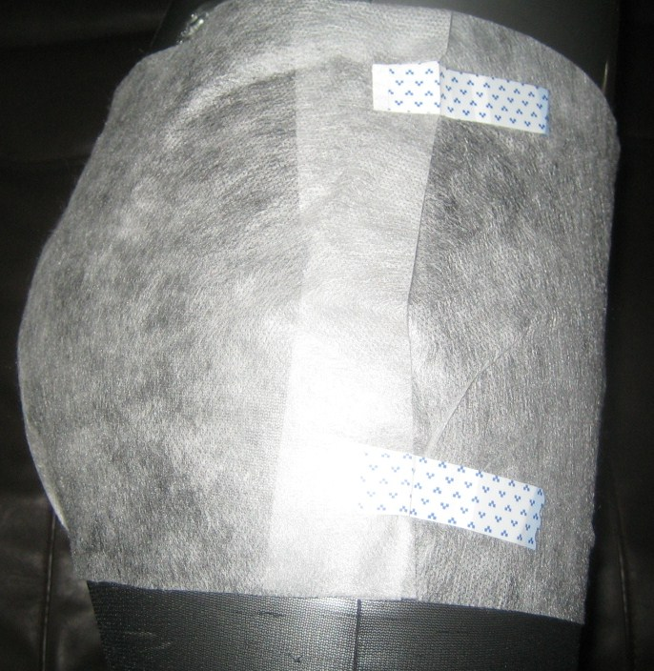

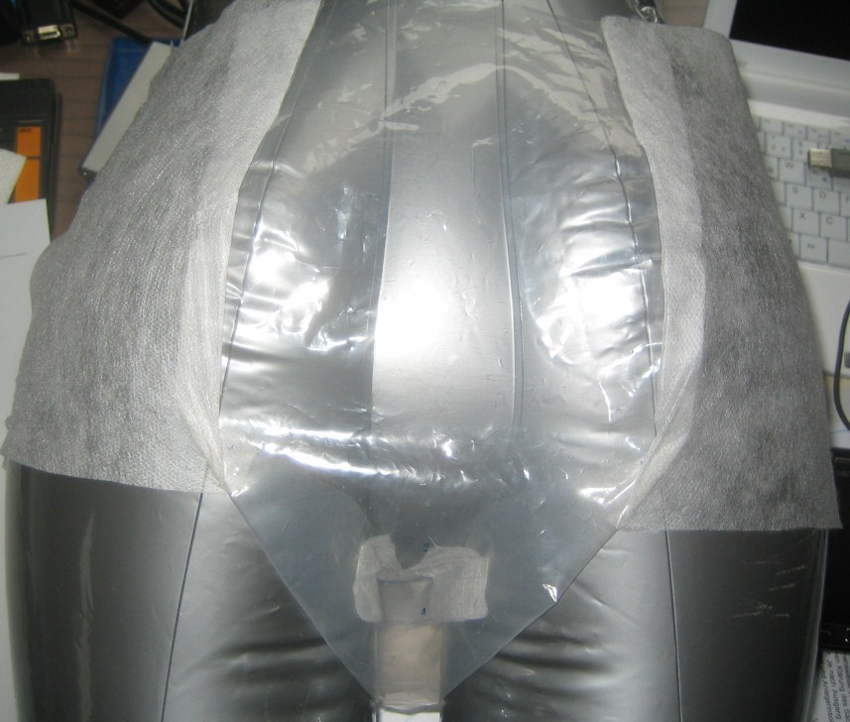

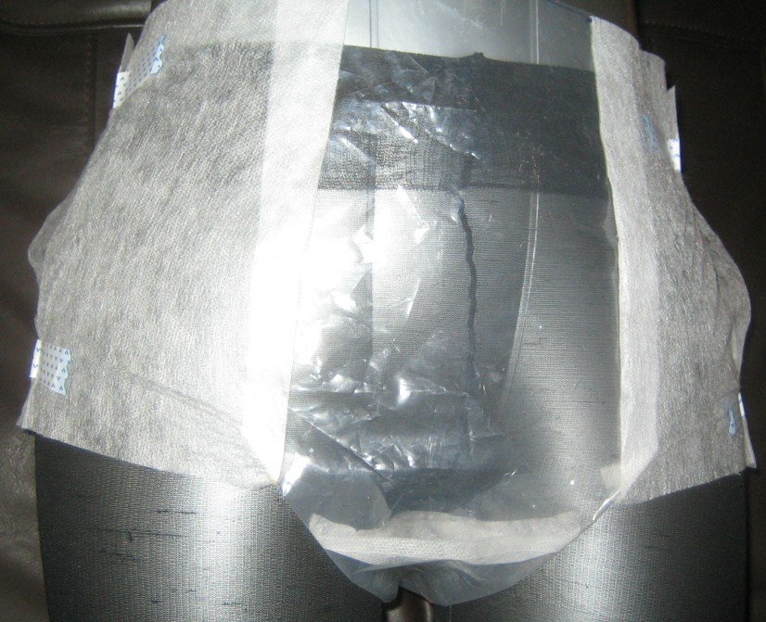
BM Trap

The leg hoops in BOCO FIT® Contour products are formed by combining the side panels to the centre piece in a specific way. The leg hoop alternatives described in other write ups on this site can be combined with features of BOCO FIT® Contour products.

* The product above features also a BM trap, i.e. it is designed to store faeces in a void volume such that the genital area of the wearer is not contaminated, and a significantly smaller skin area is affected by solid exudates.
Below a photo shot into the crotch area of a fully functional product with BM trap.

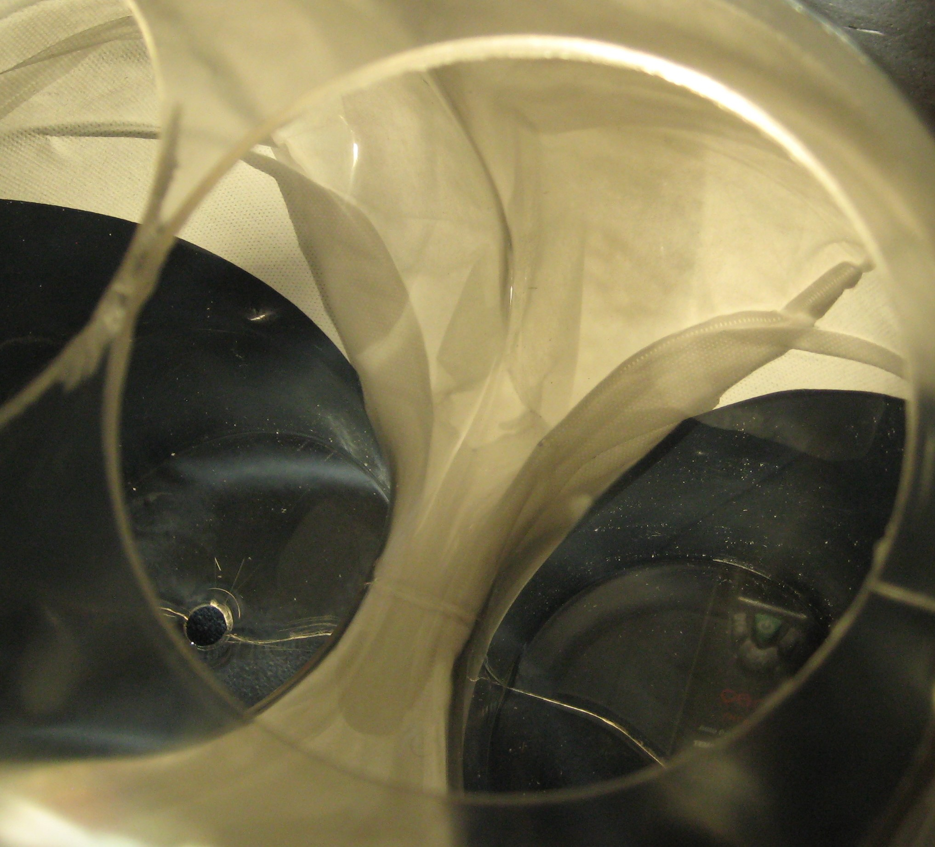
BM trap slit
opened up
due to fixation
of leg hoop to
topsheet close
to the slit

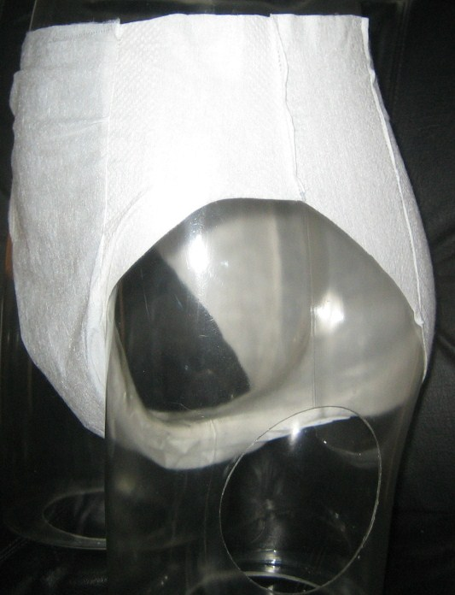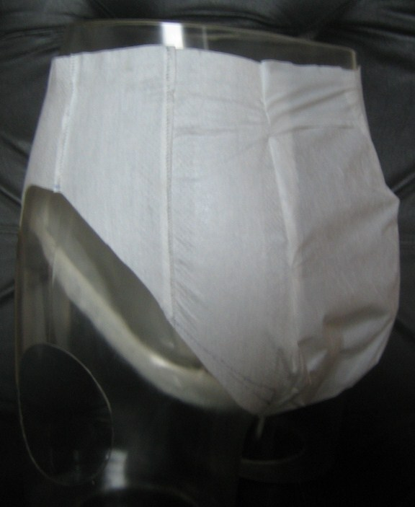
C4S
–
technical know
how & creative solutions
BOCO
Sonic
Products
-
AI Pants
-
CONTOUR
product
without
BM trap

see also
WO2015/036561

