3D Pant and Diaper Products

Products with cuffs and hoops encircling the upper legs of the wearer, and various ways to make them, have been described in earlier publications on this site. These were mostly pant type or “closed” products. Their making was based on assembling and closing the product by means of an assembly head, around which the various pieces are positioned and connected to form the finished product.
A recently published new technology allows to make 3D or, as we call them, BOdy COnforming (BOCO) products, in flat state, either as open products, or as closed products, where the closing is done further downstream of the assembly operation.

The common elements of various types of these products are so called “leg hoops”: They are needed to provide a closed circle around the leg for better sealing. For 3D diapers and pants, the hoop elements and the crotch area they limit are “flat in process” and “3D in use” - without any need for contractive elements around the legs.
Leg hoops can be formed in different ways and executions. The resulting products look slightly differently, but they all come with the key advantages of 3D products:
- they are made of less, and less sophisticated, materials
- they need no elastics
- their gentle wrap around the upper legs of the wearer prevents leakage
- their way of making is less complex than current
- they can come with zero designed in waste

There are 5 main product families defined, and some of them have several subversions. Consumers’ or manufacturers’ needs may suggest a version that fits best.

Product version 1

The latest development to make BOCO FIT as a “glue free” product uses newly developed Ultrasonic bonding technology (HELIXBOND®) to combine the leg hoop/side panel and side panel extensions (needed for wider products). The webs forming these elements are “stacked up” on top of each other, and ultrasonically bonded along curved connecting lines. When opened up and prepared for use, these products take on a 3D shape that gently fits the human body, as the shots below indicate.
A newly developed process allows to select almost any shape of the leg area for best fit and protection.
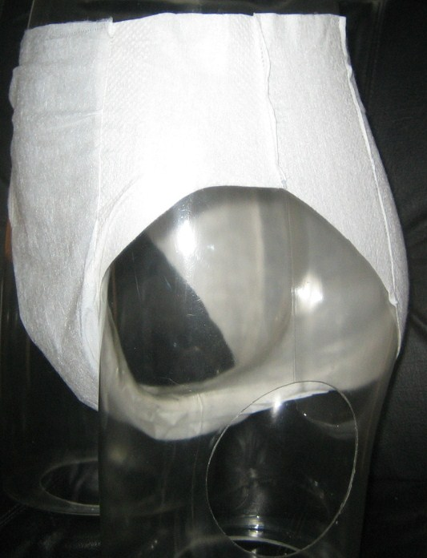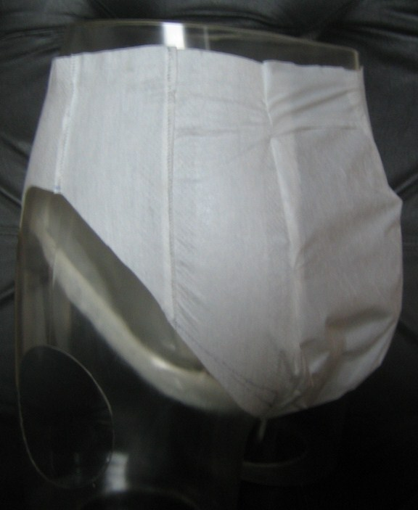
C4S
–
technical know
how & creative solutions
BOCO
Sonic
Products
-
AI Pants
-

Product version 2
side panel defines waist opening,
leg hoop defines
leg opening

Products with unitary leg hoops and side panels

Product version 3
unitary leg hoop and side
panel, optionally md elastic;
side panel defines waist
and leg opening

Products with hoops integral with centre piece

Product version 4
leg hoops integral with
centre piece,
side panels define waist
opening,
leg hoops and side
panels define leg
opening,
leg hoops may be
elasticated

